**Azure Function**

Azure Functions is a serverless compute service that enables you to run event-driven code without managing infrastructure.

Azure Functions, focusing on triggers, bindings, security, logging, monitoring, Durable Functions and Cosmos DB.

**Azure Function Prerequisites**

* Before we start, make sure you have the following:
* An [Azure subscription](https://azure.microsoft.com/en-in/pricing/offers/ms-azr-0017g/)(you can create a free account if you don’t have one).
* [Azure Functions Core Tools](https://learn.microsoft.com/en-us/azure/azure-functions/functions-run-local?tabs=windows%2Cportal%2Cv2%2Cbash&pivots=programming-language-csharp#install-the-azure-functions-core-tools) (for local development).
* [Visual Studio Code](https://code.visualstudio.com/) / Visual Studio
* Basic knowledge of C# programming.

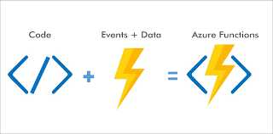

**Planning: Consumption & Premium Plan**

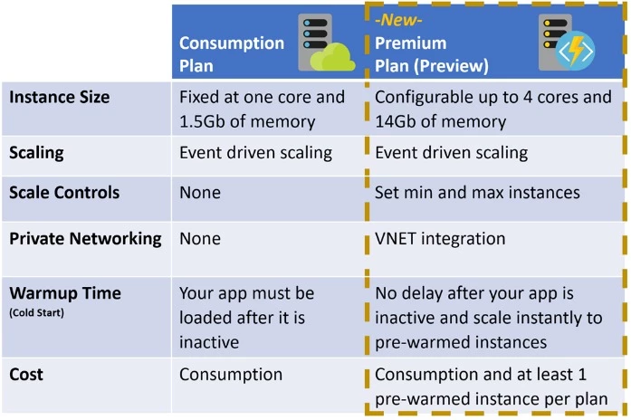

**1. Triggers**

Triggers define how a function is invoked. It’s the event that starts the execution of your function.

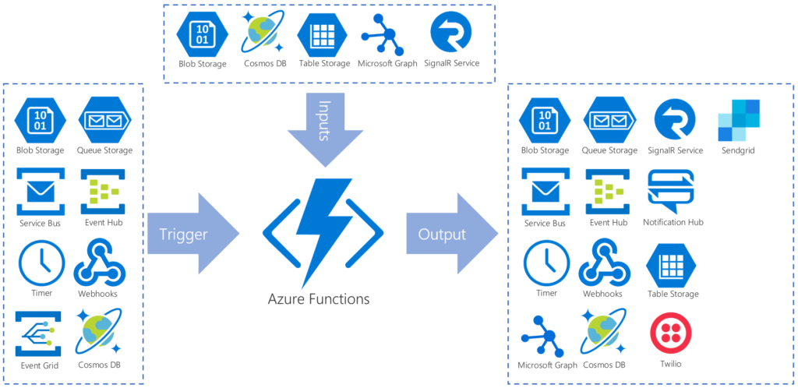

**Types of Triggers & Bindings**:

* **HTTP Trigger**: Invokes the function via HTTP requests (GET, POST, etc.).  HTTP request length is limited to 100 MB
* **Timer Trigger**: Runs the function on a specified schedule (e.g., every 5 minutes).
* **Blob Trigger**: Starts the function when a blob is added or updated in Azure Storage.
* **Queue Trigger**: Invokes the function when a new message is placed in an Azure Storage queue.
* **Event Grid Trigger**: Responds to events delivered by Event Grid.
* **Cosmos DB Trigger**: Executes when documents change in a specified collection within a Cosmos DB database.
* **Service Bus Trigger**: Starts the function when a message is received in a Service Bus queue or topic.

**. Bindings:** Bindings are declarative ways to connect data to your function. They abstract away the boilerplate code needed to access external resources.

* **Input Bindings**: Fetch data from sources like Azure Storage, Cosmos DB, or external services into the function.
* **Output Bindings**: Send data from the function to external resources like databases, queues, or other services.
* **Common Bindings**:
  + **Blob Storage Binding**: Input or output data to/from Azure Blob Storage.
  + **Cosmos DB Binding**: Connect to Cosmos DB to read or write documents.
  + **Queue Storage Binding**: Send or receive messages to/from Azure Storage queues.

**Demo – Create Azure function on Azure Portal**

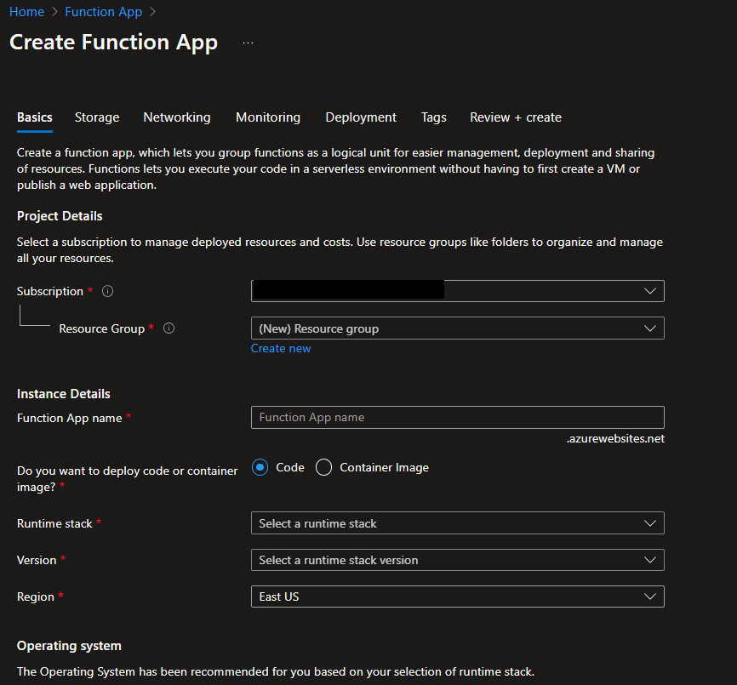

From the **Overview** panel, select the **Functions** tab, and then select **Create in the Azure portal**.

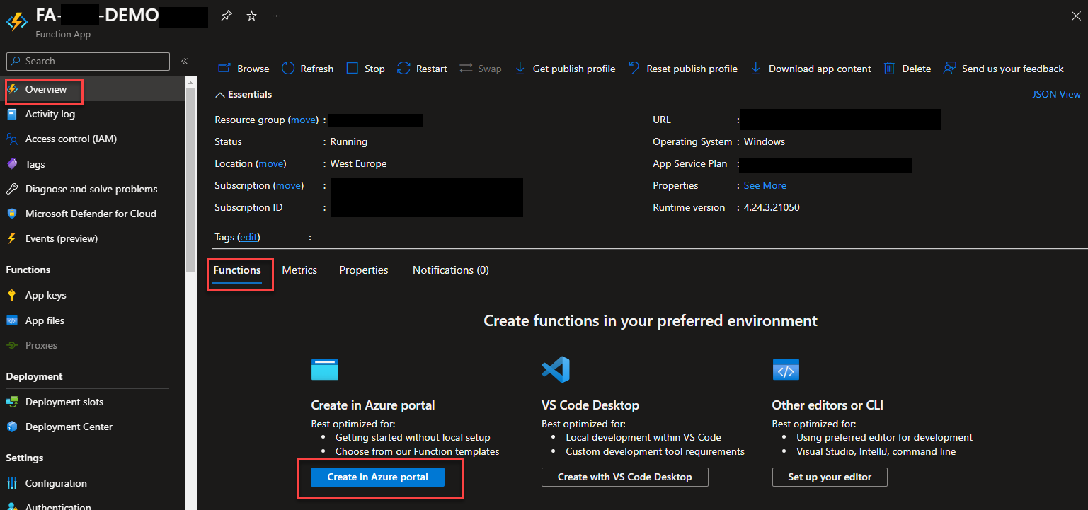

In the **Create Function** window, keep the **Development environment** property set to **Develop in portal**, and then go ahead to choose the **HTTP trigger** template. Define a proper name and **Authorization level** on the **Template Details**. Click **Create**.

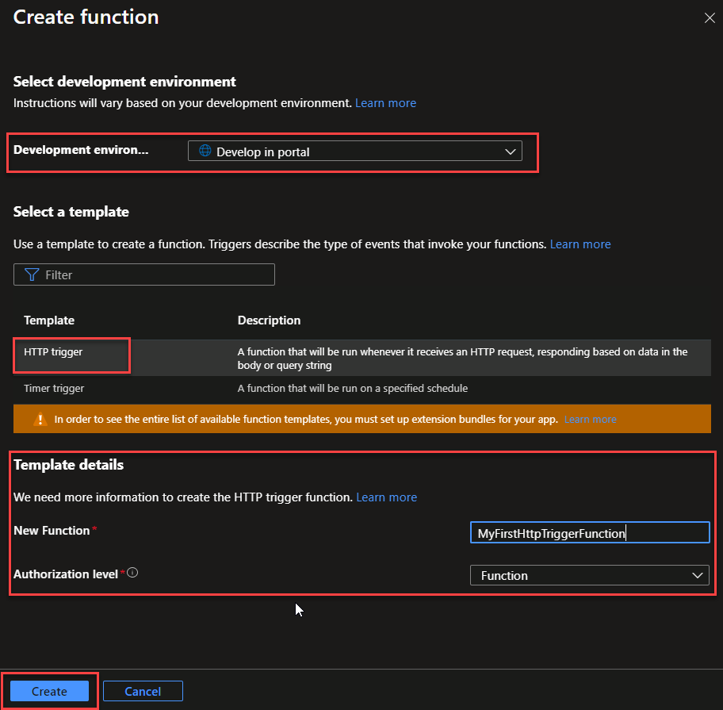

* **Configure Trigger**: Specify the HTTP method (e.g., GET, POST) and other settings for the HTTP trigger.
  + Once Azure creates the HTTP trigger function, you will be redirected to the Azure function page we created above. There, from the left tree, select the option **Integration**.
  + Select **HTTP (req)** from the **Trigger** block on the **Integration** panel, and on the**Edit trigger** panel, under**Selected HTTP methods**, select the desired HTTP methods. And **Save** the changes.

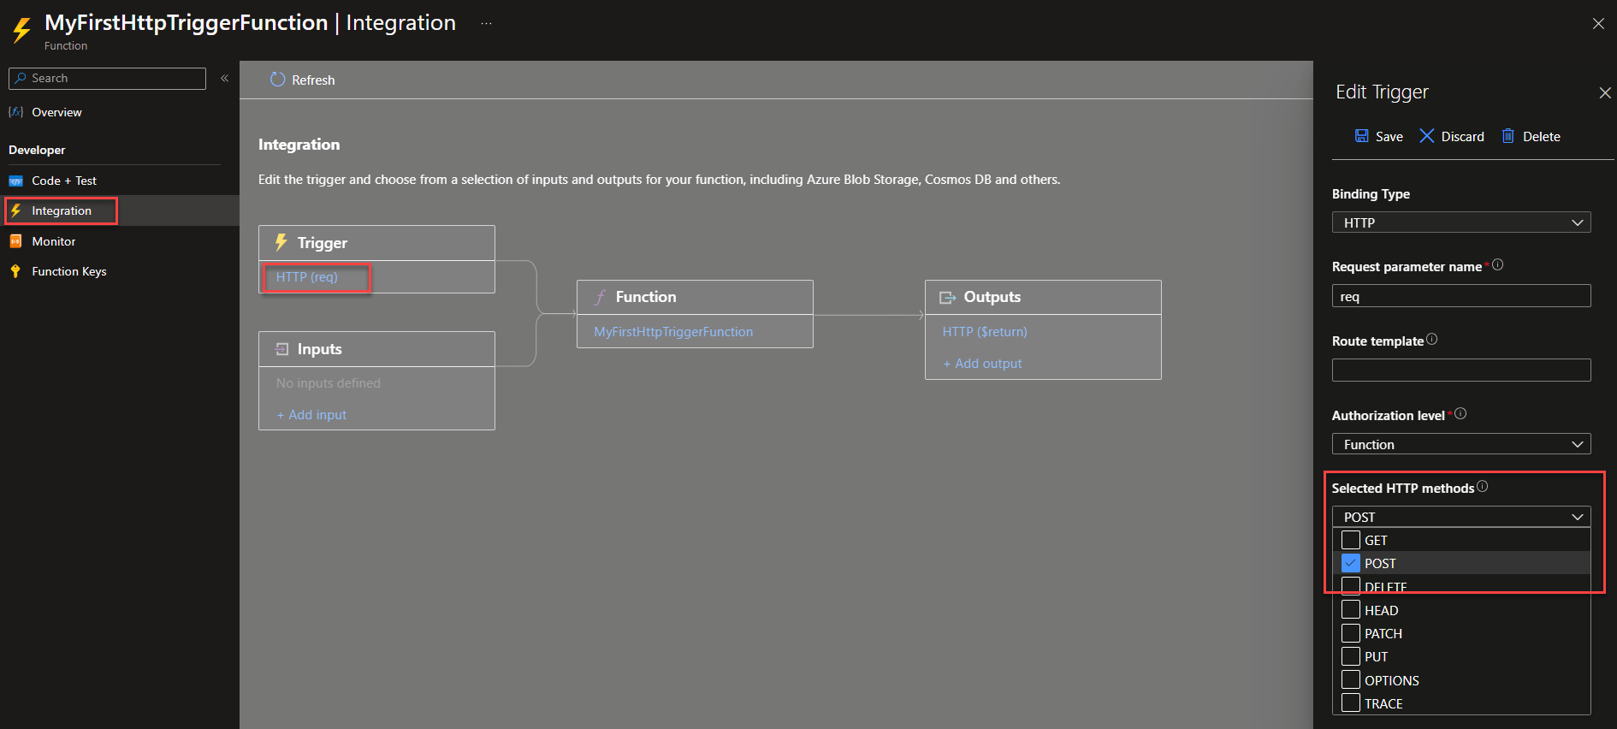

* **Function Code**: Write the code for your function. This code will be executed whenever an HTTP request is made to the trigger’s endpoint.
  + On the Azure function page, from the left tree, select the option **Code + Test.** Then, you can make the necessary changes to the code and click **Save**.

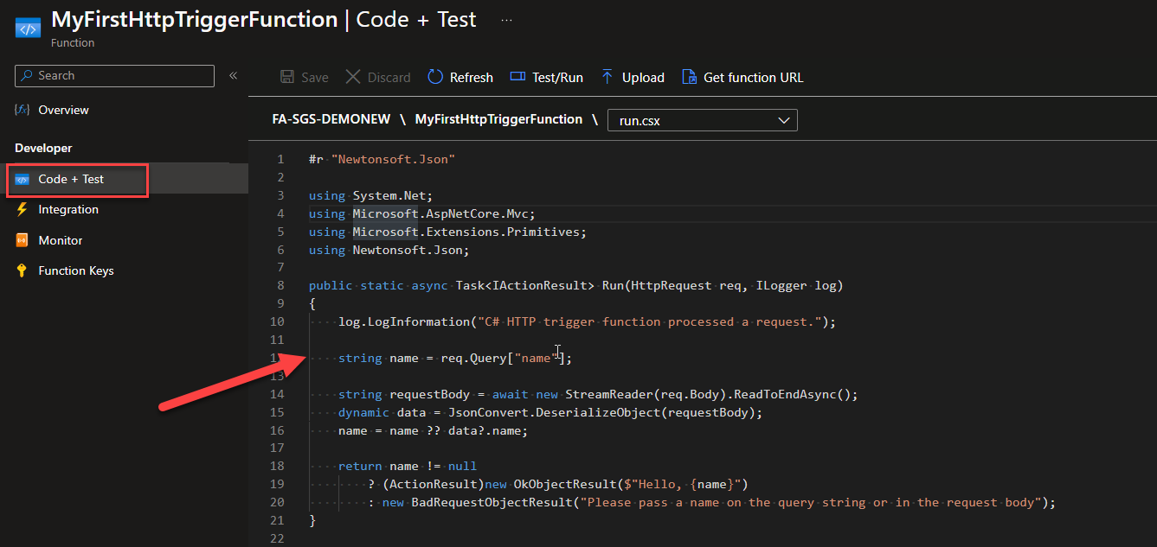

**Testing**: You can test your HTTP-triggered function using tools like cURL and Postman or by directly accessing the function’s URL in a web browser.

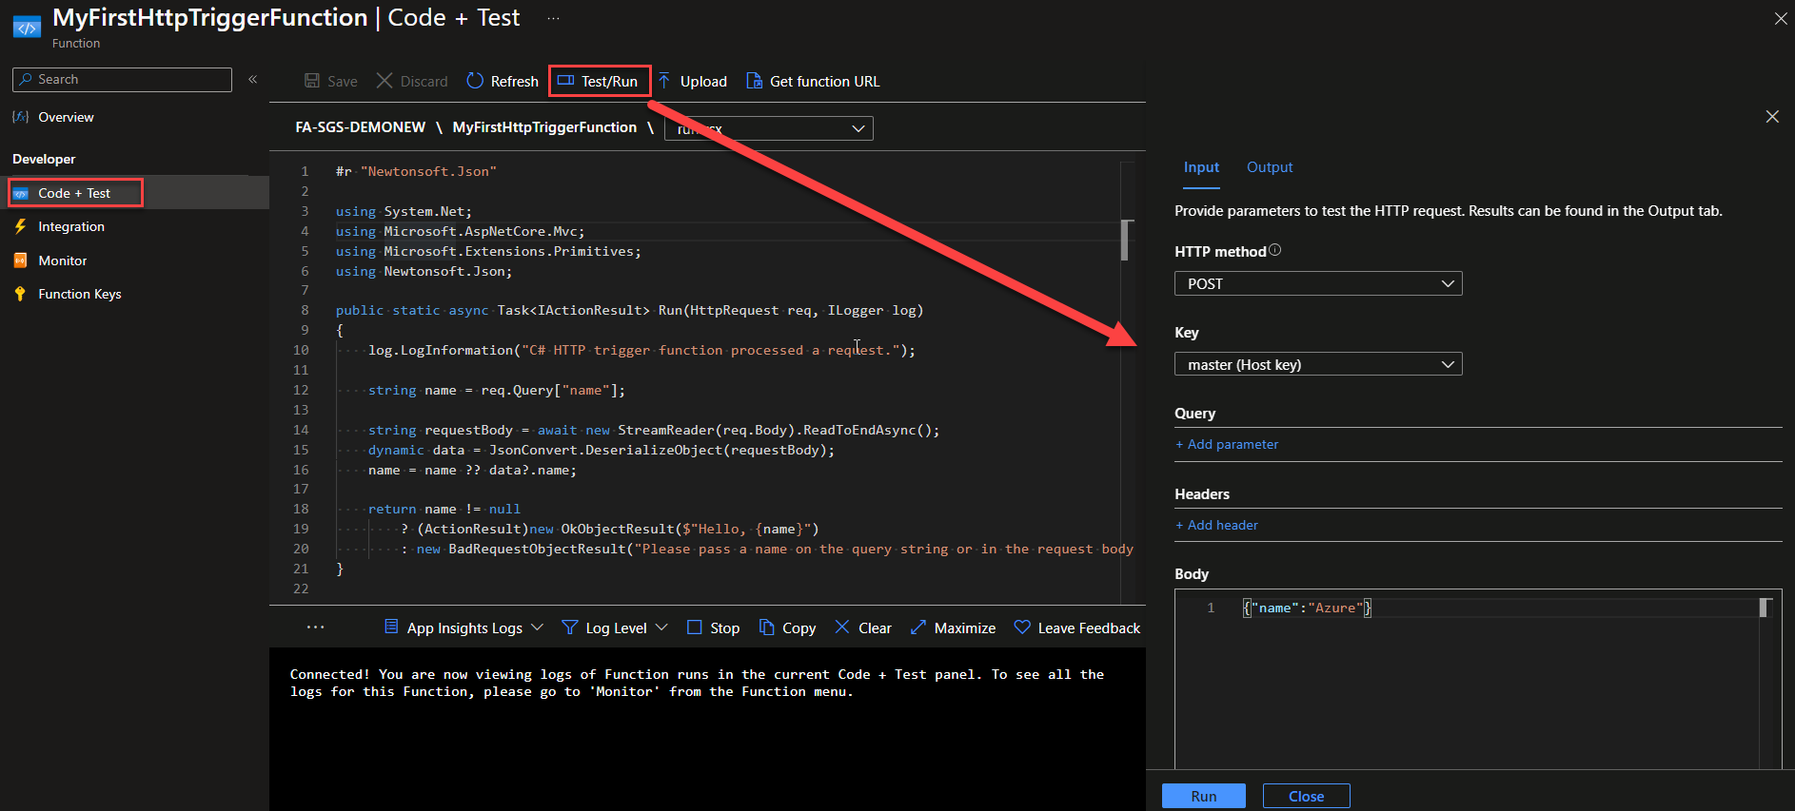

## **Demo – setup Up Azure Function locally**

## Configure the project for local development

1. In **Solution Explorer**, right-click your project node and select **Add** > **New Azure Function**.
2. Enter a **Name** for the class, and then select **Add**.

Choose your trigger, set the required binding properties, and then select **Add**. The following example shows the settings for creating a Queue storage trigger function.

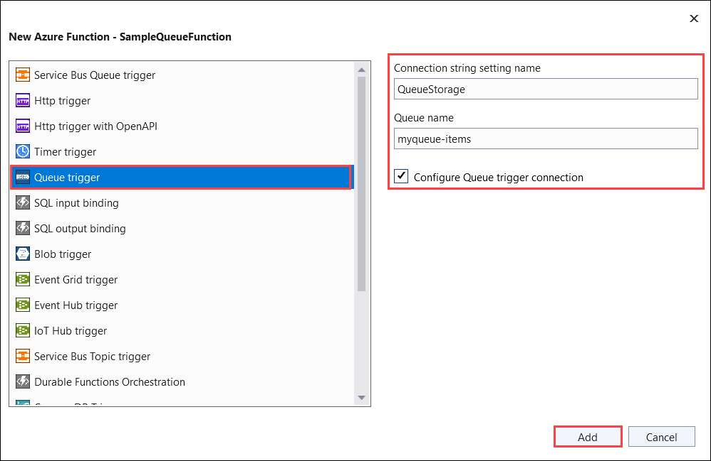

|  |
| --- |
| using System;  using Azure.Storage.Queues.Models;  using Microsoft.Azure.Functions.Worker;  using Microsoft.Extensions.Logging;  namespace Company.Function  {  public class QueueTriggerCSharp  {  private readonly ILogger<QueueTriggerCSharp> _logger;  public QueueTriggerCSharp(ILogger<QueueTriggerCSharp> logger)  {  _logger = logger;  }  [Function(nameof(QueueTriggerCSharp))]  **public void Run([QueueTrigger("PathValue", Connection = "ConnectionValue")] QueueMessage message)**  {  _logger.LogInformation($"C# Queue trigger function processed: {message.MessageText}");  }  }  } |

## **Run functions locally**

To start your function in Visual Studio in debug mode:

1. Press F5. If prompted, accept the request from Visual Studio to download and install Azure Functions Core (CLI) tools. You might also need to enable a firewall exception so that the tools can handle HTTP requests.

## **Publish to Azure**

1. In **Solution Explorer**, right-click the project and select **Publish**. In **Target**, select **Azure**, and then select **Next**.

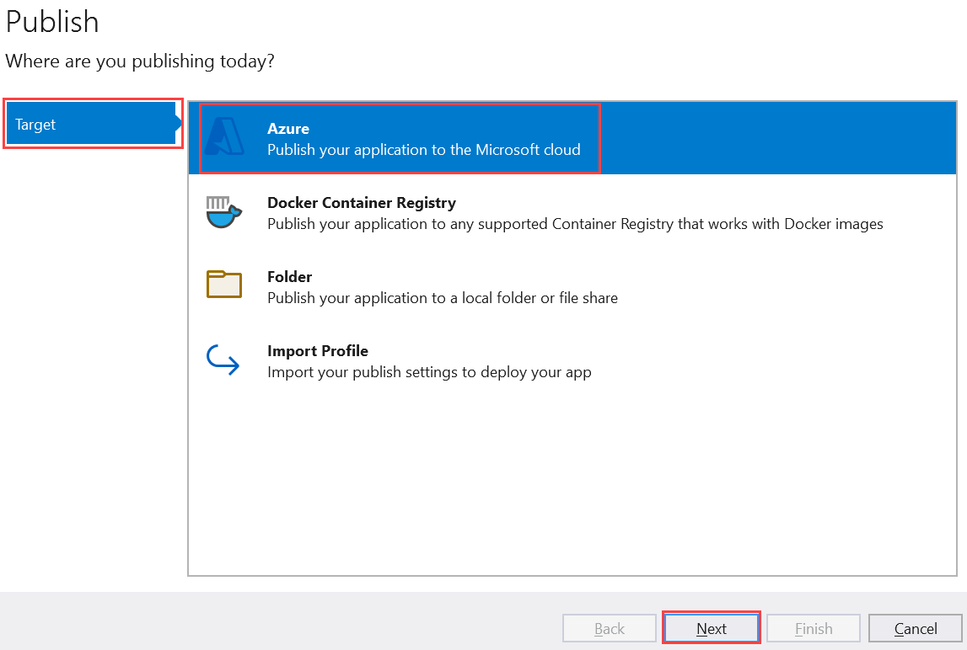

1. On **Specific target**, select **Azure Function App (Windows)**. A function app that runs on Windows is created. Select **Next**.

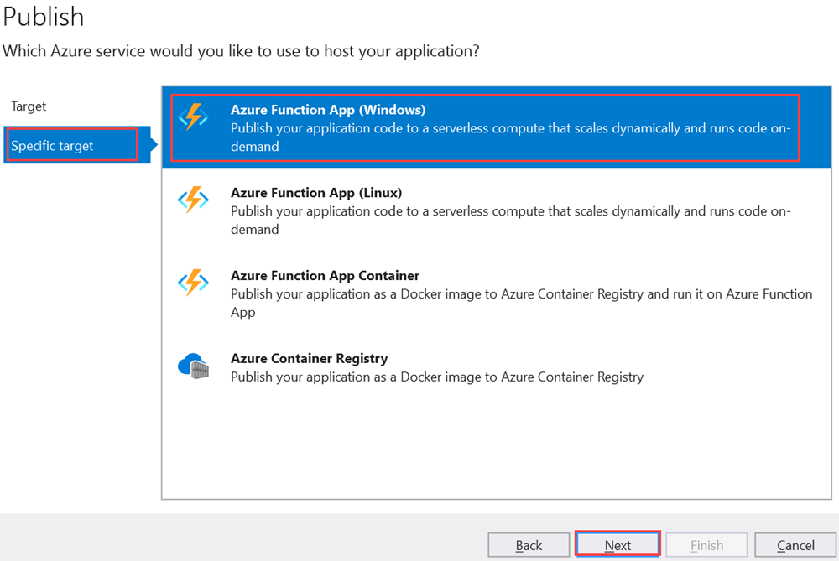

1. On **Functions instance**, select **Create a new Azure Function**.

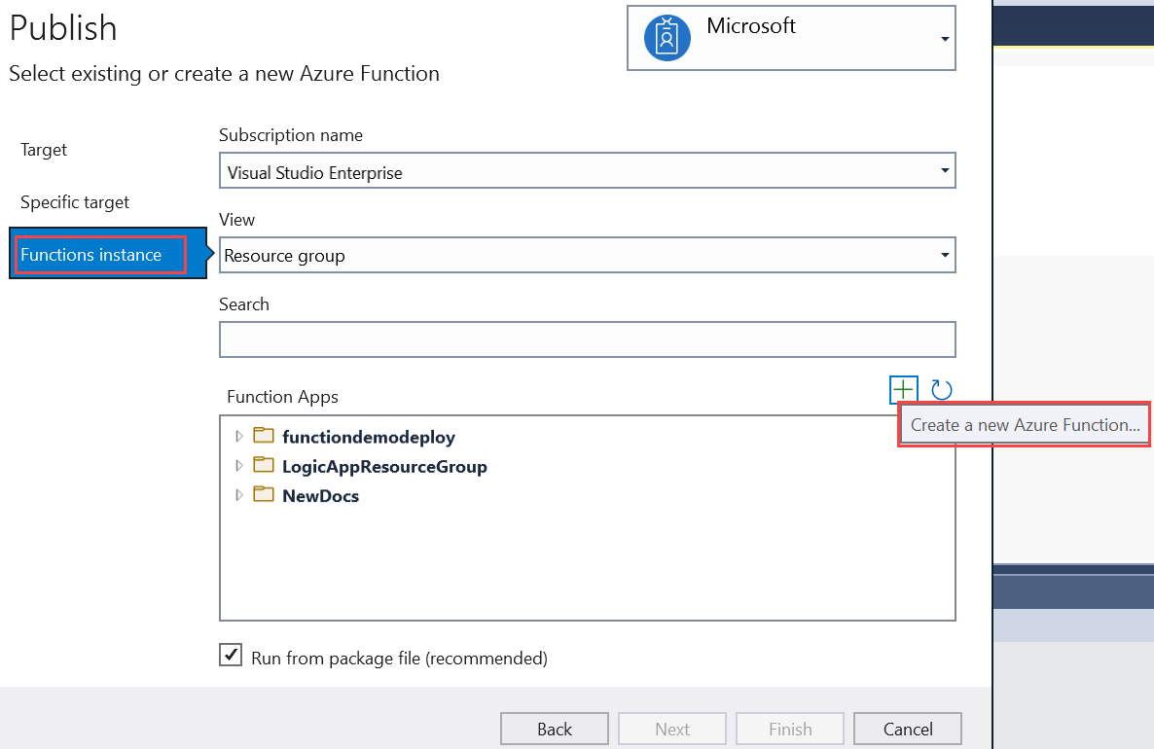

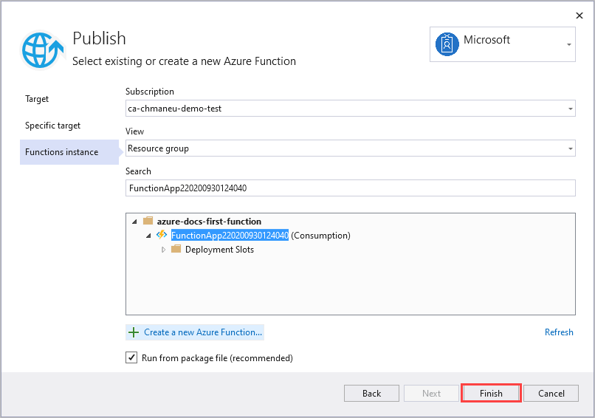

Select **Finish**, and on the **Publish** pane, select **Publish** to deploy the package that contains your project files to your new function app in Azure.

When deployment is completed, the root URL of the function app in Azure is shown on the **Publish** tab.

On the **Publish** tab, in the **Hosting** section, select **Open in Azure portal**. The new function app Azure resource opens in the Azure portal.

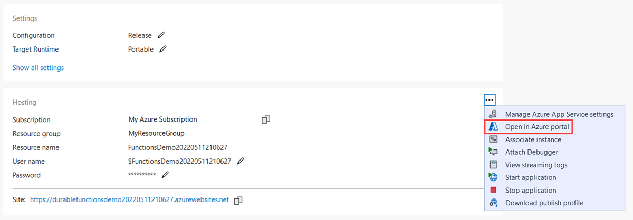

**Example - HTTP Trigger:**

**Library:**

Microsoft.Azure.WebJobs;

Microsoft.Azure.WebJobs.Extensions.Http;

Microsoft.Extensions.Logging;

**Example :**

using System;

using System.IO;

using Microsoft.AspNetCore.Mvc;

using Microsoft.Azure.WebJobs;

using Microsoft.Azure.WebJobs.Extensions.Http;

using Microsoft.AspNetCore.Http;

using Microsoft.Extensions.Logging;

using Newtonsoft.Json;

public static class HttpTriggeredFunction

{

[FunctionName("HttpTriggeredFunction")]

public static async Task<IActionResult> Run(

**[HttpTrigger(AuthorizationLevel.Function, "get", "post", Route = null)] HttpRequest req,**

**ILogger log)**

{

log.LogInformation("C# HTTP trigger function processed a request.");

**try**

**{**

string name = req.Query["name"];

if (string.IsNullOrEmpty(name))

{

using (StreamReader streamReader = new StreamReader(req.Body))

{

var requestBody = await streamReader.ReadToEndAsync();

dynamic data = JsonConvert.DeserializeObject(requestBody);

name = name ?? data?.name;

}

}

name = name ?? "World";

log.LogInformation($"Greeting {name}");

return new OkObjectResult($"Hello, {name}");

}

**catch (JsonException jsonEx)**

{

log.LogError(jsonEx, "Failed to deserialize JSON request body.");

return new BadRequestObjectResult("Invalid JSON format.");

}

**catch (Exception ex)**

**{**

log.LogError(ex, "An unexpected error occurred.");

return new StatusCodeResult(StatusCodes.Status500InternalServerError);

}

}

}

**Exception Handling, Security, Monitoring**

**1. Catch Blocks**: Specific exceptions are caught and handled appropriately

* **JsonException**: Catches errors related to JSON deserialization. If there's an issue with the JSON format, it returns a 400 Bad Request response with a relevant error message.
* **General Exception**: Catches any other unhandled exceptions. This helps avoid exposing detailed error information to the user and returns a 500 Internal Server Error response instead.

2. **Security Configuration**

To secure the Azure Function, you can use **function-level authorization**, **API management**, or **OAuth 2.0** with Azure Active Directory (Azure AD).

#### **Option 1: Use Function Keys (Function-Level Authorization)**

1. Set Authorization Level**: The function's authorization level is already set to Function in the [HttpTrigger] attribute, which requires a function key for access.**

[HttpTrigger(AuthorizationLevel.Function, "get", "post", Route = null)]

1. **Access Keys:**
   * Deploy your function to Azure.
   * Navigate to your Function App in the Azure portal.
   * Go to the "Functions" tab, select your function, and click on "Manage."
   * Here, you can find the Function Key (default) or create a new one.
   * Use this key in the URL: https://<your-function-app>.azurewebsites.net/api/HttpTriggeredFunction?code=<your-function-key>

#### **Option 2: Use Azure AD Authentication (OAuth 2.0)**

1. **Register the Application in Azure AD**:
   * Go to the Azure **portal**, navigate to **Azure Active Directory** > **App registrations**.
   * Register a new application and note the **Application (client) ID** and **Directory (tenant) ID**.
2. **Configure Authentication**:
   * Go to your Function App in the Azure portal.
   * Navigate to **Authentication/Authorization** and enable **App Service Authentication**.
   * Choose **Azure Active Directory** as the authentication provider.
   * Configure it using the application you registered in Azure AD.
3. **Enforce Authentication**:
   * Configure your Azure Function to require authentication by setting the authorization level to Anonymous in the [HttpTrigger] attribute and enforcing authentication via Azure AD.
   * Now, the function will only allow requests from users or applications authenticated via Azure AD.

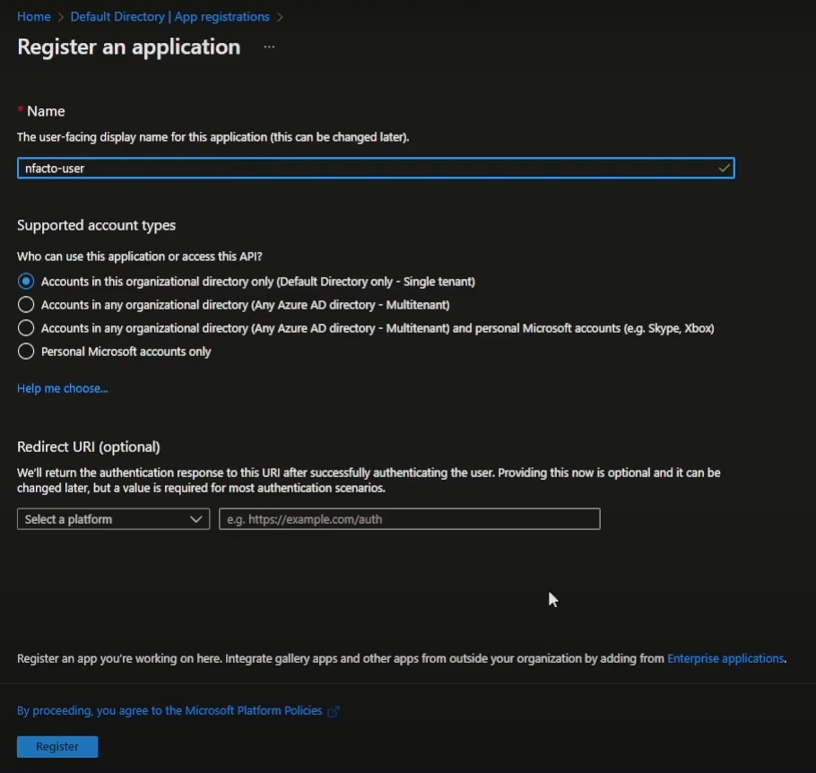

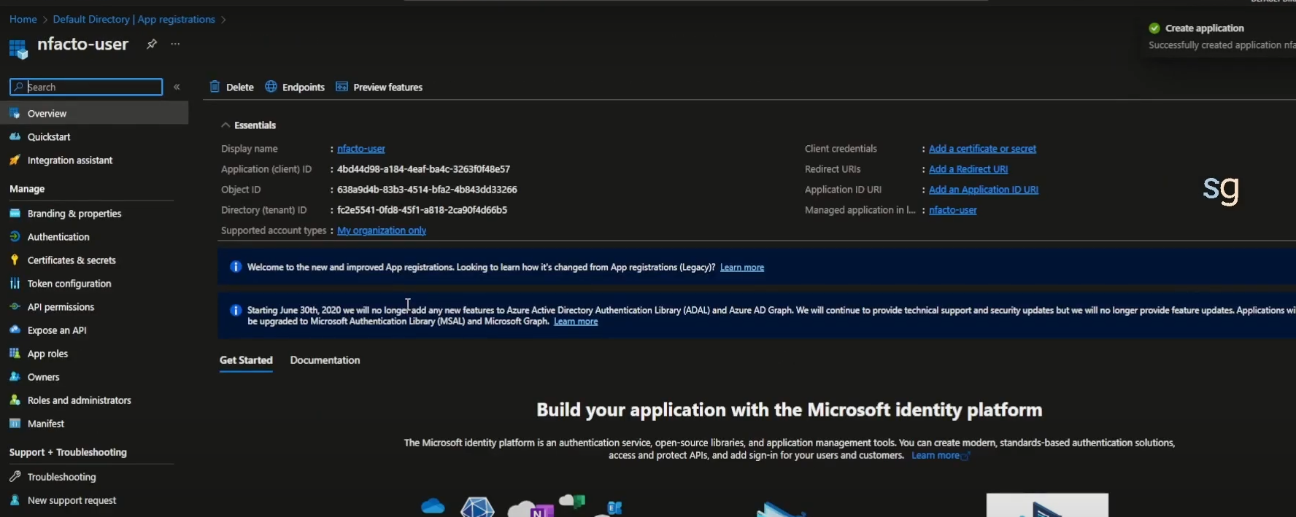

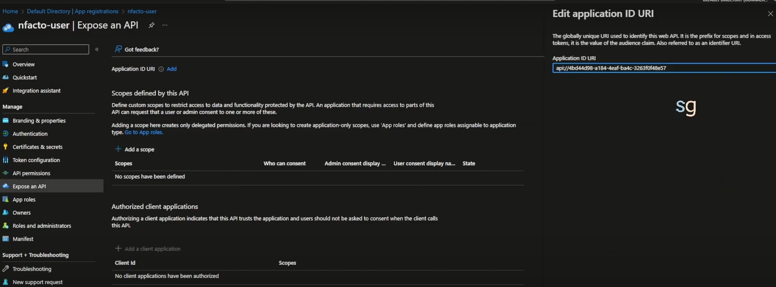 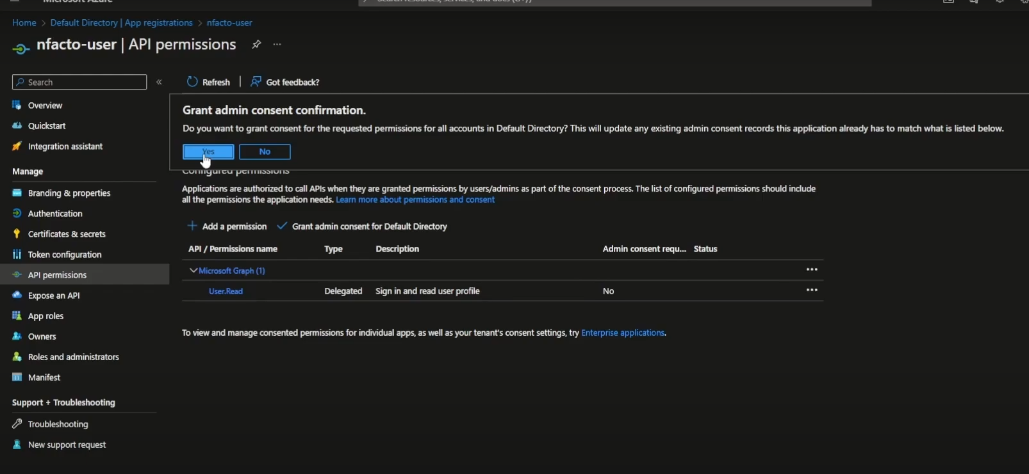

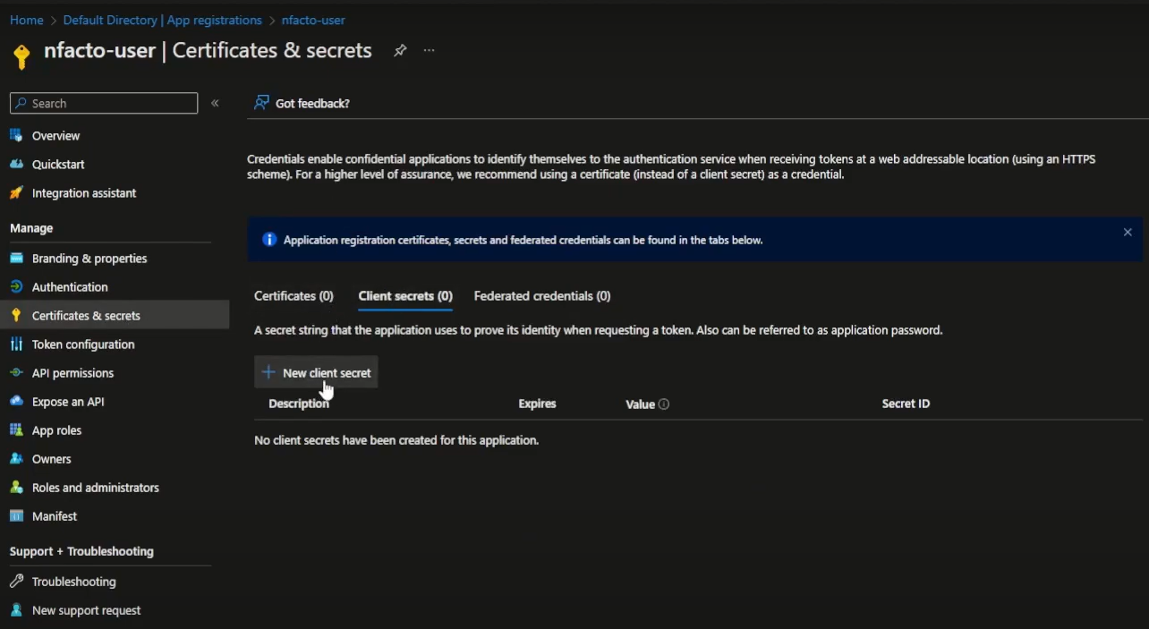

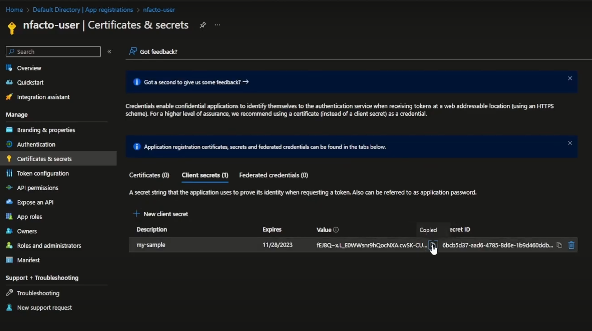

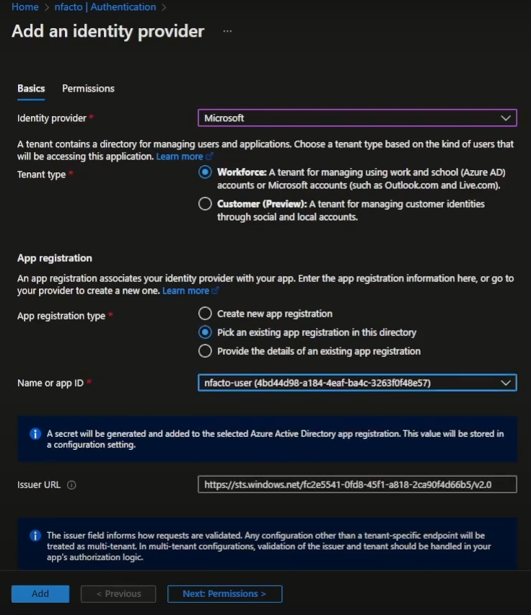

Now function app is secure with OAuth

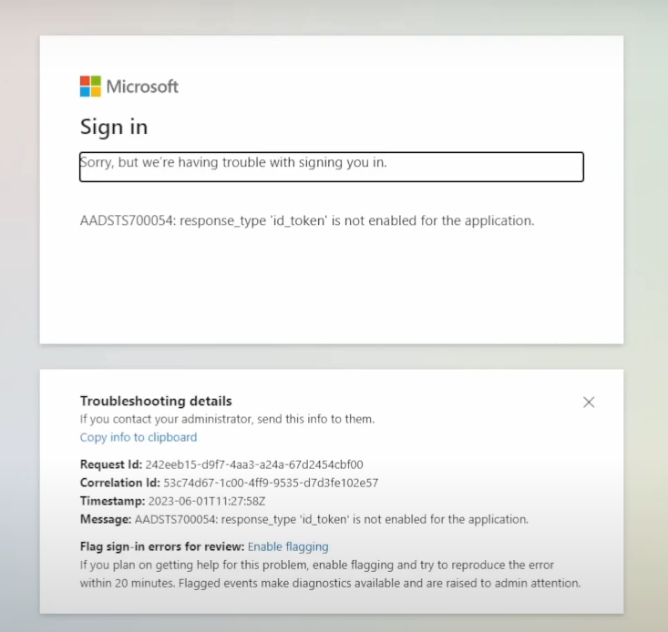

Test azure function via Azure logic app

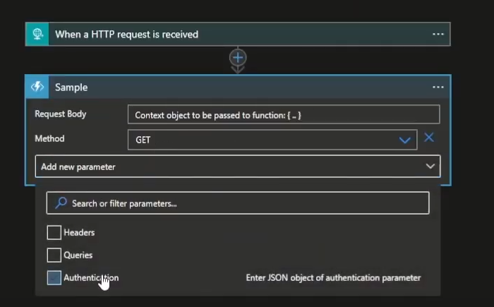

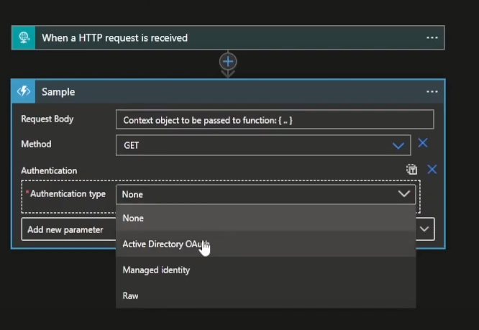

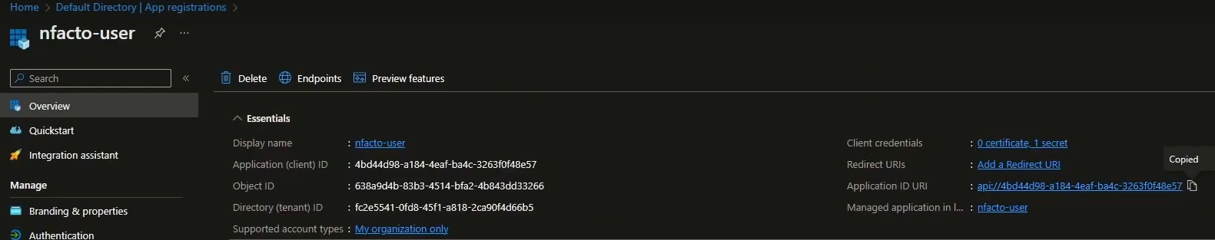

Audience is application Id

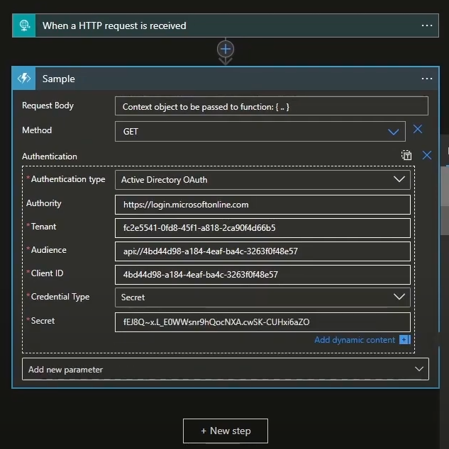

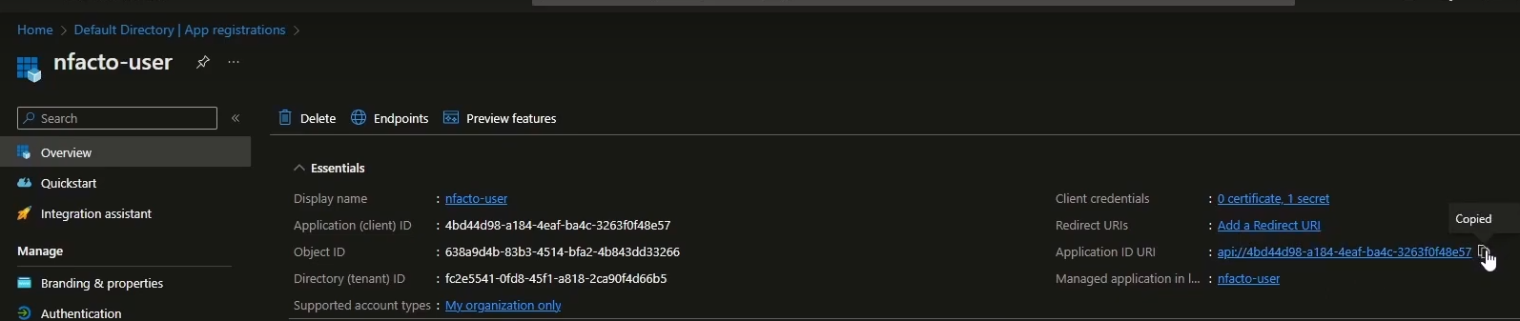

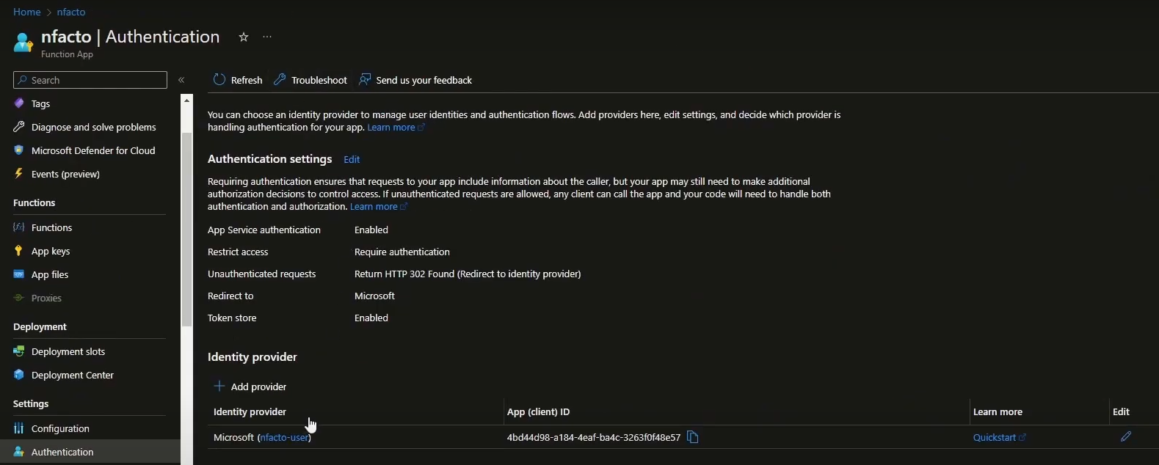

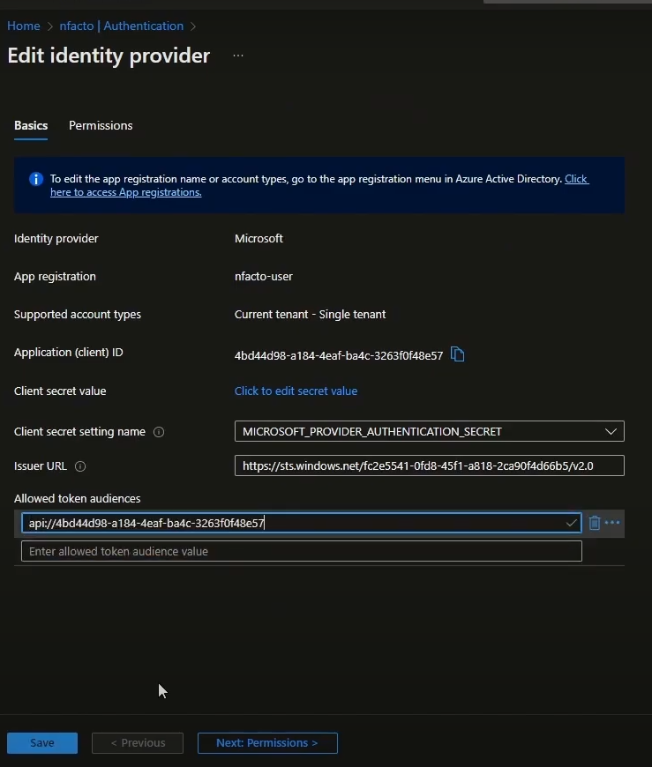

Check via Postman

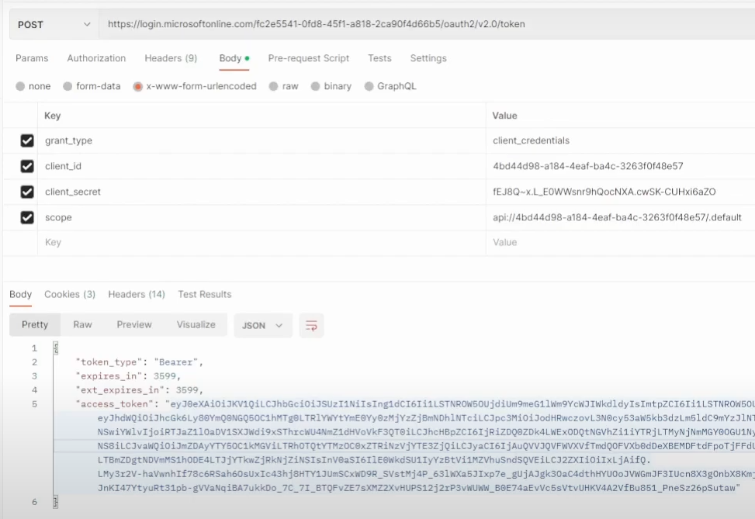

Pass token to Azure function url

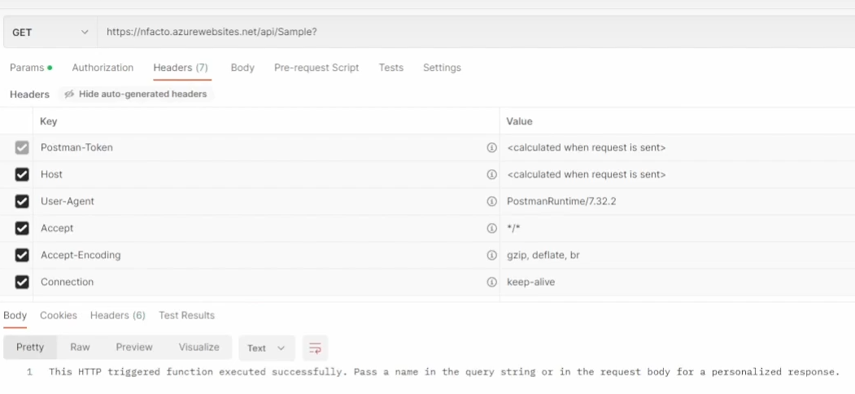

### 3 ****Logging and Monitoring Configuration****

#### Enable Application Insights for Logging

1. **Link Application Insights**:
   * In the Azure portal, go to your Function App.
   * Under "Settings," select "Application Insights."
   * Enable Application Insights and link it to an existing Application Insights resource or create a new one.
2. **Configure Logging in Code**:
   * Use the ILogger instance in your function to log information, warnings, and errors.
   * Example: log.LogInformation("This is a log message.");
3. **View Logs**:
   * Go to the linked Application Insights resource in the Azure portal.
   * Use the "Live Metrics Stream" or "Logs" to view the function's telemetry data.

**Add Application Insights and Logging in Your Function App Code**

1. **Install NuGet Packages**:
   * Open your function app project in Visual Studio or your preferred IDE.
   * Add the following NuGet packages to your project:
     + Microsoft.Azure.WebJobs.Extensions.Http
     + Microsoft.Extensions.Logging
     + Microsoft.ApplicationInsights.AspNetCore
     + Microsoft.ApplicationInsights.WorkerService
2. **Configure Logging in Your Function App**:
   * In your Startup.cs or Program.cs file, configure logging and Application Insights:

|  |
| --- |
| using Microsoft.Azure.Functions.Worker;  using Microsoft.Azure.Functions.Worker.Http;  using Microsoft.Extensions.Logging;  public class MyHttpTriggerFunction  {  private readonly ILogger _logger;  public MyHttpTriggerFunction(ILoggerFactory loggerFactory)  {  _logger = loggerFactory.CreateLogger<MyHttpTriggerFunction>();  }  [Function("MyHttpTriggerFunction")]  public async Task<HttpResponseData> Run([HttpTrigger(AuthorizationLevel.Function, "get", "post")] HttpRequestData req)  {  _logger.LogInformation("C# HTTP trigger function processed a request.");  // Your function logic here  var response = req.CreateResponse(HttpStatusCode.OK);  response.Headers.Add("Content-Type", "text/plain; charset=utf-8");  await response.WriteStringAsync("Hello, World!");  return response;  }  } |

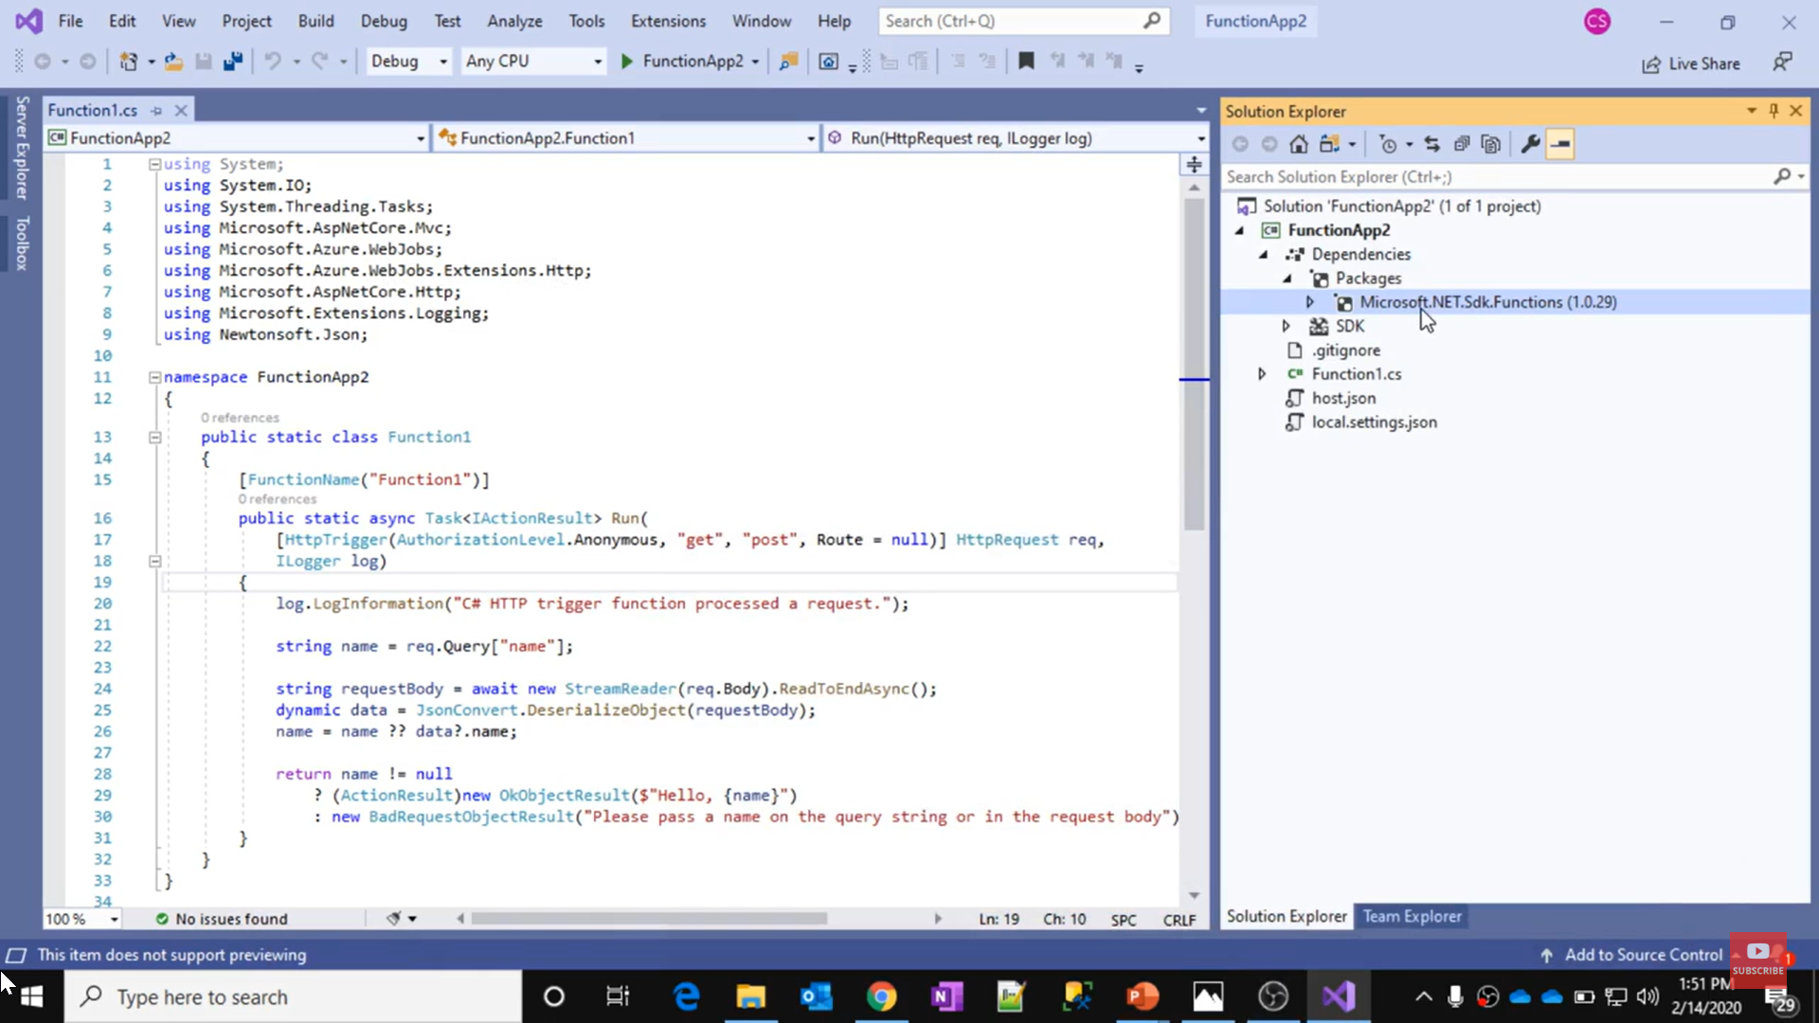

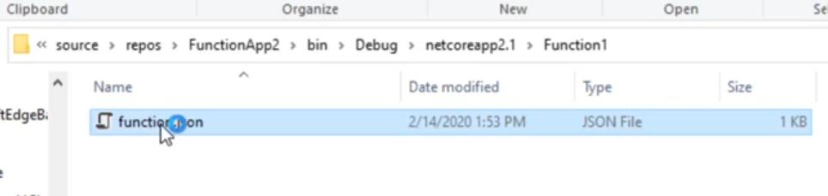

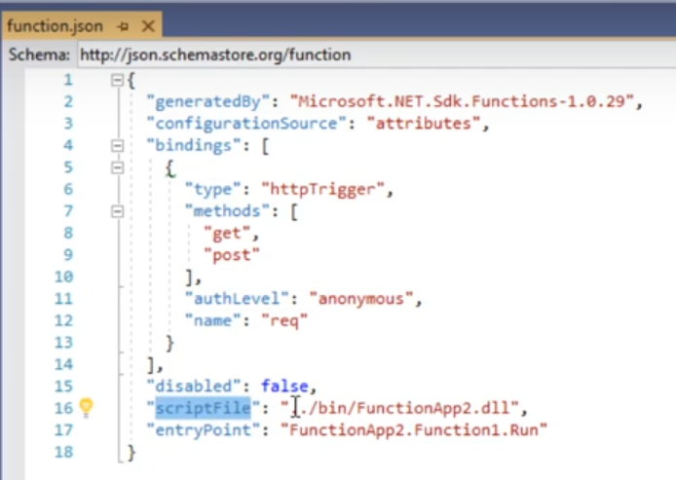

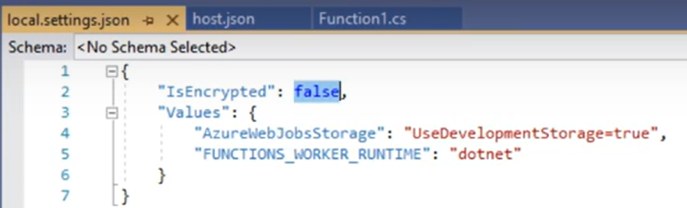 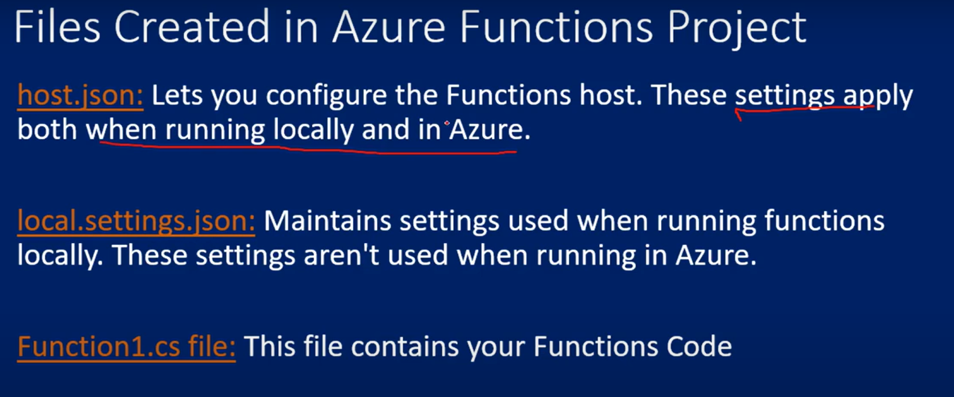

#### Monitor Performance and Errors

1. **Set Up Alerts**:
   * In the Azure portal, navigate to your Application Insights resource.
   * Go to "Alerts" and create alert rules for specific metrics like failed requests, slow performance, or high memory usage.
2. **Analyze Application Performance**:
   * Use the "Performance" and "Failures" tabs in Application Insights to view detailed telemetry about the function’s execution times and any errors.
3. **Enable Distributed Tracing**:
   * Distributed tracing allows you to follow requests through various services.
   * Ensure that your Application Insights is configured to collect correlation data.

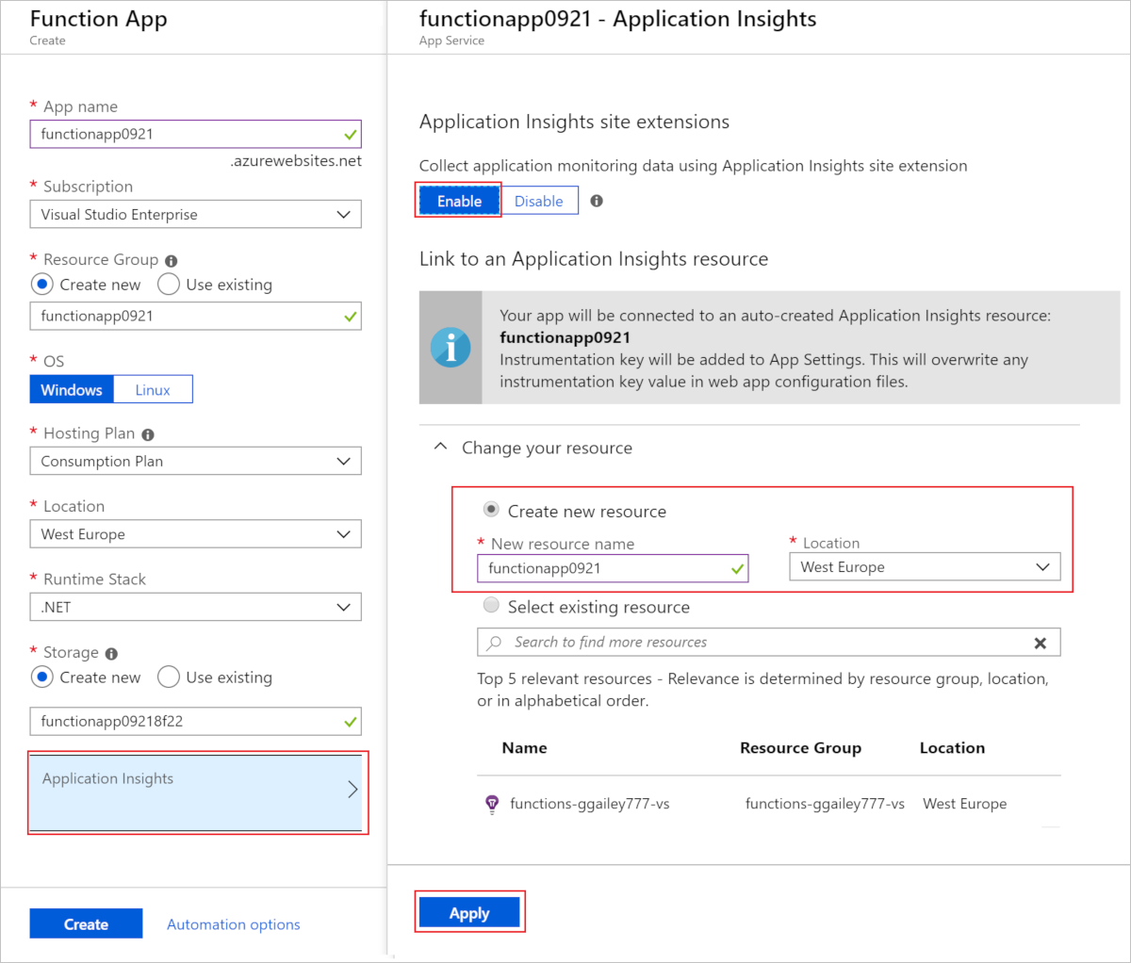

Choose **Logs** to explore or query for logged events.

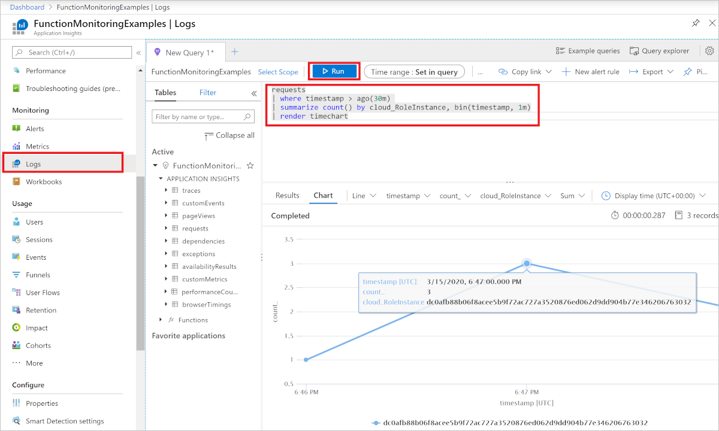

Here's a query example that shows the distribution of requests per worker over the last 30 minutes.

KustoCopy

requests

| where timestamp > ago(30m)

| summarize count() by cloud_RoleInstance, bin(timestamp, 1m)

| render timechart

* The following screenshot shows the Host.Results telemetry data displayed in the function **Monitor** tab:

[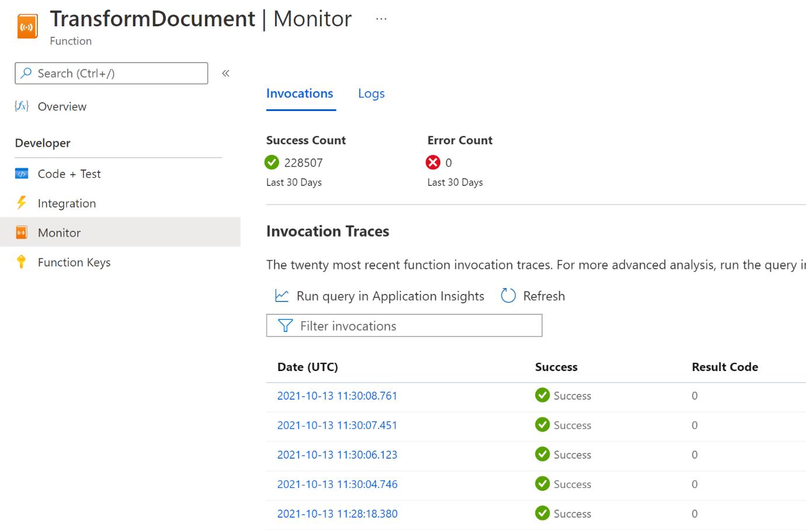](https://learn.microsoft.com/en-us/azure/azure-functions/media/configure-monitoring/host-results-function-monitor-big.png#lightbox)

The following screenshot shows Host.Results telemetry data displayed in Application Insights Performance dashboard:

[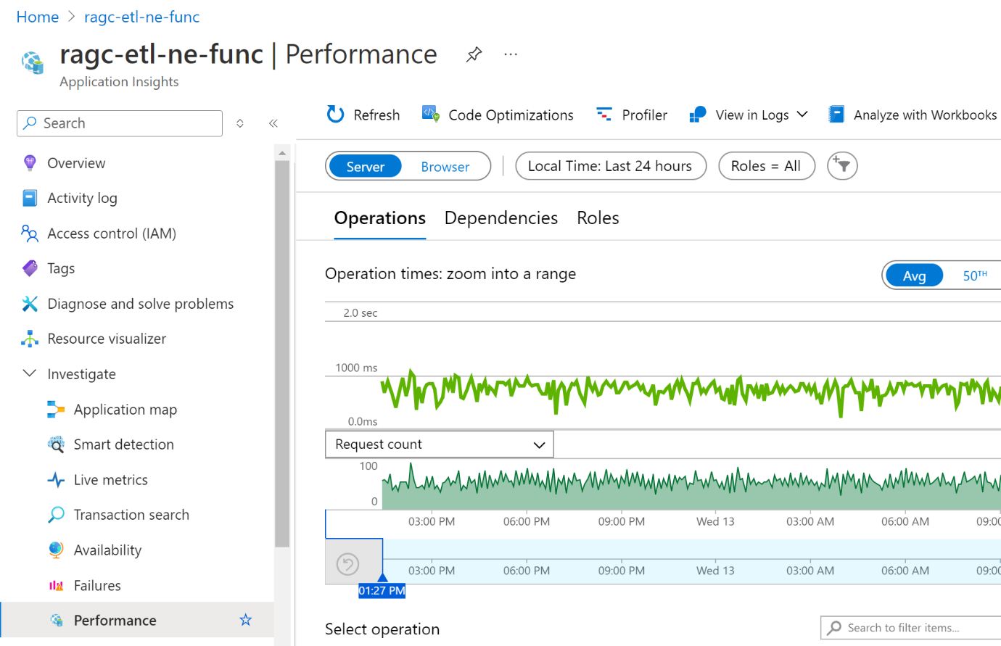](https://learn.microsoft.com/en-us/azure/azure-functions/media/configure-monitoring/host-results-application-insights-big.png#lightbox)

{

"version": "2.0",

"logging": {

"logLevel": {

"default": "Warning",

"Function": "Error",

"Host.Aggregator": "Error",

"Host.Results": "Information",

"Function.Function1": "Information",

"Function.Function1.User": "Error"

},

"applicationInsights": {

"samplingSettings": {

"isEnabled": true,

"maxTelemetryItemsPerSecond": 1,

"excludedTypes": "Exception"

}

}

}

}

### 4. ****Deploy the Function to Azure****

After adding the security, logging, and monitoring configurations:

1. **Deploy the Function**:
   * In Visual Studio, right-click on your project and select **Publish**.
   * Choose your Azure subscription and the Function App you’ve set up.
   * Deploy the function.

### 5. ****Testing and Validation****

#### Test Security:

* Access the function using the HTTP URL with the required function key.
* If using Azure AD, authenticate the user and test access.

#### Validate Logging and Monitoring:

* Trigger the function and check if logs are appearing in Application Insights.
* Monitor live metrics to ensure everything is functioning correctly.

**==========**

**3. HTTP Triggers (GET, POST)**

* **HTTP Methods**:
  + **GET**: Typically used to retrieve data.
  + **POST**: Used to send data to the server (e.g., create a resource).
  + **PUT/PATCH**: Used to update resources.
  + **DELETE**: Used to delete resources.
* **Securing HTTP Triggers**:
  + **API Keys**: Can be used to secure your function endpoints.
  + **OAuth/JWT Tokens**: For more secure and standardized authentication, you can integrate Azure AD or other identity providers.
  + **CORS**: Configuring Cross-Origin Resource Sharing (CORS) to restrict access from different domains.

**4. Security**

* **Authentication/Authorization**: Azure Functions support built-in authentication using Azure AD, Microsoft Accounts, Google, Facebook, Twitter, etc.
* **Managed Identity**: Azure Functions can use Managed Identity to securely access Azure resources like Key Vault, Storage, Cosmos DB without managing credentials.
* **API Management**: You can front Azure Functions with Azure API Management for additional security layers, like rate limiting, IP filtering, and custom policies.
* **TLS/SSL**: Secure HTTP endpoints using HTTPS.

**5. Logging and Monitoring**

* **Application Insights**: Azure Functions integrate with Application Insights for logging and monitoring, which provides:
  + **Real-time monitoring**: View live metrics and performance data.
  + **Custom logging**: Use the ILogger interface to log custom information.
  + **Distributed tracing**: Track the flow of requests through various services.
* **Monitoring Metrics**:
  + **Function Execution Count**: Number of times a function is triggered.
  + **Success/Failure Rate**: Percentage of successful executions.
  + **Execution Time**: Time taken for a function to execute.
  + **Memory Usage**: Monitor memory consumption.
* **Azure Monitor**: Monitor and diagnose your functions with detailed metrics, logs, and alerts.

**6. Durable Functions**

* **Overview**: Durable Functions is an extension of Azure Functions that allows you to write stateful functions in a serverless environment.
* **Patterns**:
  + **Function Chaining**: Sequential execution of functions.
  + **Fan-Out/Fan-In**: Parallel execution of functions with aggregation of results.
  + **Async HTTP APIs**: Managing long-running operations with durable functions.
  + **Human Interaction**: Pause and wait for external events.
* **Orchestrator Function**: Coordinates the execution of multiple functions.
* **Activity Function**: Performs the actual work and can be triggered by the orchestrator.

**7. Storage and Cosmos DB Integration**

* **Blob Storage**:
  + **Blob Trigger**: Automatically triggers a function when a new blob is uploaded or modified.
  + **Blob Binding**: Read from or write to Blob Storage within your function.
* **Cosmos DB**:
  + **Cosmos DB Trigger**: Respond to changes in a Cosmos DB collection.
  + **Cosmos DB Binding**: Bind input/output data to/from Cosmos DB.
  + **Partitioning and Scaling**: Handle large-scale data operations using Cosmos DB’s partitioning capabilities.

**Common Interview Questions**

1. **Explain the difference between triggers and bindings in Azure Functions.**
2. **How would you secure an HTTP triggered Azure Function?**
3. **Describe how you would monitor and log an Azure Function.**
4. **What is a Durable Function, and how does it differ from a regular Azure Function?**
5. **How do you handle long-running processes in Azure Functions?**
6. **What is the role of an orchestrator function in Durable Functions?**
7. **Can you describe how you would use Cosmos DB with Azure Functions?**
8. **What are the best practices for handling errors and retries in Azure Functions?**